|  |
| --- |
|  |
|  |

**HLD Title: CDAC Data management**

|  |  |  |  |
| --- | --- | --- | --- |
|  | | | |
| Prepared by | **Role** | **Change Date** | **Comments** |
| Shweta | Business Analyst | 07-May-2016 |  |
| Owned by | Designation & Contact | Change Date | Comments |
| Sanjay | Functional Consultant | 21-may-2016 |  |
| Authorised by | Designation & Contact | Change Date | Comments |
| Susan Alex |  |  |  |
| Reviewer’s Name | Role | Change Date | Comments |
| Sunil | Technical Consultant |  |  |
| Sanjay | Functional Consultant |  |  |

**Do Not Copy**

**Hard Copies of this document are for Reference Only for most recent please visit** [**http://softctrl.in**](http://softctrl.in)**.**

Contents

1 Introduction 4

1.1 Introduction 4

1.1.1 Out of scope 4

1.2 Requirements 5

1.2.1 Requirements for CAs 5

1.2.2 Requirements for CMOs 6

1.2.3 Requirements for Cos 6

1.2.4 Miscellaneous/Common/Operational requirements 7

1.3 Change Log 7

1.4 Wireframes 7

2 RAID 8

2.1 Risks 8

2.2 Assumptions 8

2.3 Issues 8

2.4 Design Decisions & Constraints 8

3 Solution Outline 9

4 Static Design 9

4.1 Static Architecture 9

4.2 Data Model 9

5 Migration Impacts 10

5.1 Legacy Access Database 10

6 Dynamic Design 10

6.1 Use Cases – 10

6.1.1 CMO Creating ARC 10

6.1.2 License Fee management 10

License fee management 11

6.1.3 ATC creation by ARC/CO 11

6.1.4 Inward Book management 12

6.1.5 Student inquiry management 13

6.1.6 Students registration management 14

6.1.7 Online examination 16

7 Interface Changes 17

8 Detailed Low level impacts 17

9 Transition Plan 17

10 Process Impact 18

*TBD* 18

11 E2E Testing Strategy 18

*TBD* 18

12 Non Functional 18

13 Financial Aspects 18

13.1 Option A 18

13.1.1 Development 18

13.1.2 Iteration / Feedback / Bug Fix / UAT 18

13.1.3 Maintenance (AMC) 18

13.2 Option B 19

13.2.1 Development 19

13.2.2 Iteration / Feedback / Bug Fix / UAT 19

13.2.3 Maintenance (AMC) 19

14 Appendix 19

Data mapping sheet 19

15 Glossary 19

C-DAC 20

ARC 20

ATC 20

CA 20

CMO 20

CO 20

FA 20

# Introduction

## Introduction

This design gives the high level solution for the work flow management of C-DAC operations. C-DAC, along with managing the activities of its own centers, manages the ARCs (Authorized Regional Coordinator), ATCs (Authorized Training Centre). The document outlines the process flow of all the interactions between these centers, functionalities within the centers and the technical implementation behind these functionalities.

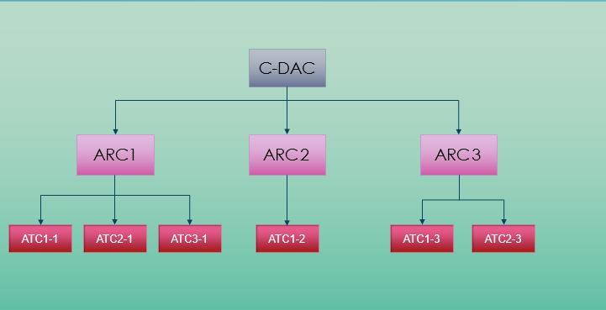

C-DAC affiliates ARCs that in-turn affiliates ATCs. C-DAC can affiliate as many number of ARCs so as ARCs can affiliate ATCs. There is a defined process workflow for each of the journeys between C-DAC to ARCs and ARCs to ATCs. ARCs and ATCs can provide trainings to the students and C-DAC facilitates the required aid and materials to do so. There are many transactions happening between each of these layers, such as exchange of student enrolment details, fees shared, affiliation payments, study materials and many more.

There are users like C-DAC admin(s) referred to as **CA**, operator(s) (at CDAC, ARC or ATC) referred to as **CO**, Centre Management Operator(s) referred to as **CMO**, and other regular users (roles to be defined later). These users have specified business roles to responsible to perform their own set of operations. Section 4.2 details the Business roles to users mapping.

This document covers the details of these transactions and how they are conducted and who is responsible to conduct these operations.

Section 1.2 lists the high level requirements and further sections describe the technical details for these requirement implementations.

### Out of scope

## Requirements

### Requirements for CAs

|  |  |  |  |
| --- | --- | --- | --- |
| **Requirement No** | **Summary** | **Compliance** | **Comments** |
| R_1.1 | CAs to be able to create CMO records |  |  |
| R_1.2 | CAs to be able to create CO records |  |  |
| R_1.3 | CAs to be able to create new states |  |  |
| R_1.4 | CAs to be able to assign COs to states. |  |  |
| R_1.5 | CAs to be able to create and assign Grades to states. |  |  |
| R_1.6 | CAs to create license agreements and license cost (new license cost and renewal cost) |  |  |
| R_1.7 | CAs to be able to add license cost/license renewal cost to ARCs. |  |  |
| R_1.8 | CAs to be able to manage Photo ID creation/distribution. |  |  |
| R_1.9 | CAs to be able to create prospectus charges. |  |  |
| R_1.10 | CAs to be able to manage charges applicable for ATC locations change requests, Name change requests, owner change requests. |  |  |
| R_1.11 | CAs to be able to configure and manage the charges applicable for changes related to certificates, duplicate certificate requests. |  |  |
| R_1.12 | CAs to be able to configure and manage the charges applicable for re-examination requirements, re-authorization requirements. |  |  |
| R_1.13 | CAs to be able to add grades and change grades. |  |  |
| R_1.14 | CAs to be able to add new courses. |  |  |
| R_1.15 | CAs to be able to map the courses to the states, map grades to the states and define fees w.r.t the grades. |  |  |
| R_1.16 | CAs to be able to map the books for the new courses added, modify books to the existing courses. |  |  |
| R_1.17 | CAs to be able to define the minimum number of books for ARCs |  |  |
| R_1.18 | CAs to be able to set max book reprint at C-DAC level. |  |  |
| R_1.19 | CAs to be able to verify the ARC payment details and approve/reject the request. |  | Dependent on R_2 |
| R_1.20 | CAs to be able to define the payment installment dates for the ARC verification requests if payment has not happened. |  |  |

### Requirements for CMOs

|  |  |  |  |
| --- | --- | --- | --- |
| **Requirement No** | **Summary** | **Compliance** | **Comments** |
| R_2.1 | CMOs to be able to create new ARC records with payment details |  |  |
| R_2.2 | CMOs to be able to submit the request to CA for payment verification. |  |  |
| R_2.3 | CMOs to add the installment payment details and submit the request to CA for approval |  |  |
| R_2.4 | CMOs to submit the physical copy of the payment details to FA |  |  |
| R_2.5 | CMOs to manage inward/outward prospectus |  |  |
|  |  |  |  |

### Requirements for Cos

|  |  |  |  |
| --- | --- | --- | --- |
| **Requirement No** | **Summary** | **Compliance** | **Comments** |
| R_3.1 | COs to create new ATC records. |  |  |
| R_2.2 | COs to submit the payment details to CA for verification |  |  |
| R_2.3 | COs to manage the Students’ payments |  |  |
| R_2.4 |  |  |  |
| R_2.5 |  |  |  |
|  |  |  |  |

### Miscellaneous/Common/Operational requirements

|  |  |  |  |
| --- | --- | --- | --- |
| **Requirement No** | **Summary** | **Compliance** | **Comments** |
| R_4.1 | Courier management between the entities (C-DAC, ARC, ATC) |  |  |
| R_4.2 | Payment management between the entities. |  |  |
| R_4.3 | Book management (requests/amendments) between the entities. |  |  |
| R_4.4 | Online examination and courses linked to online examination and its management. |  |  |
| R_4.5 | Corporate project management between entities. – Project status, resource utilization, deployment schedule, change request management. |  |  |
| R_4.6 | Grievance management |  |  |
| R_4.7 | Interview and placement management. |  |  |
| R_4.8 | Faculty Management |  |  |
| R_4.9 | Report extraction – Students/ARCs/ATCs/Payments/Courses/Books |  |  |

## Change Log

|  |  |  |  |
| --- | --- | --- | --- |
| **Version** | **Date** | **Author** | **Details** |
| Draft 0.1 | 07/05/2016 | Shweta | Initial Draft |
| Draft 0.2 | 25/05/2016 | Shweta | Updated the process flow for all the use cases. |
| Draft 0.3 | 22/06/2016 | Sunil | Removed the prospectus workflow, as prospectus will no longer be printed and will be available online, the sequence is to be maintained by the system separate brochure. |
| Draft 0.4 | 23/06/2016 | Sunil | Added Estimated Efforts. |

## Wireframes

TBA

# RAID

## Risks

|  |  |  |
| --- | --- | --- |
| **Reference** | **Description** | **Mitigation** |
| R_01 | Any change to the initial requirements, if any raised at the later stage of the development phase will have additional cost and timelines incurred. | These requests are to be managed with change control. |
| R_02 | Legacy / Old database information not available. | Legacy / Old database (structure and data) to be shared. |
|  |  |  |

## Assumptions

|  |  |
| --- | --- |
| **Reference** | **Description** |
| A_01 | All the requirements listed are assumed based on the flow chart diagram shared. |
| A_02 | Low level details of each module and requirement will be completed once the detailed discussions are conducted. |
| A_03 | E2E testing strategy, Technical details of each module/requirement/workflow to be completed at the later stage of the design discussions. |

## Issues

|  |  |  |  |  |
| --- | --- | --- | --- | --- |
| **Reference** | **Description** | **Resolution** | **Owner** | **Status** |
| I_01 | What is the data retention requirement?  How long the Students’ data be retained in the database? |  | Business owner | Open |
| I_02 | * Once prospectus is outward, CMO to update the stock count? * CMO can inward if the state selected by CMO is under ARC that is handled by CMO? * CO to update the inward details if state is not under this ARC? * At what point is it updated? After the prospectus has been received or at the time it is sent out? | Prospectus workflow is eliminated and it not to be considered for this solution. |  |  |

## Design Decisions & Constraints

|  |  |
| --- | --- |
| **Reference** | **Description** |
| D_01 |  |

# Solution Outline

# 

# Static Design

## Static Architecture

This section will include the technical architecture of the systems and interfaces once the detailed technical solution is outlined.

## Data Model

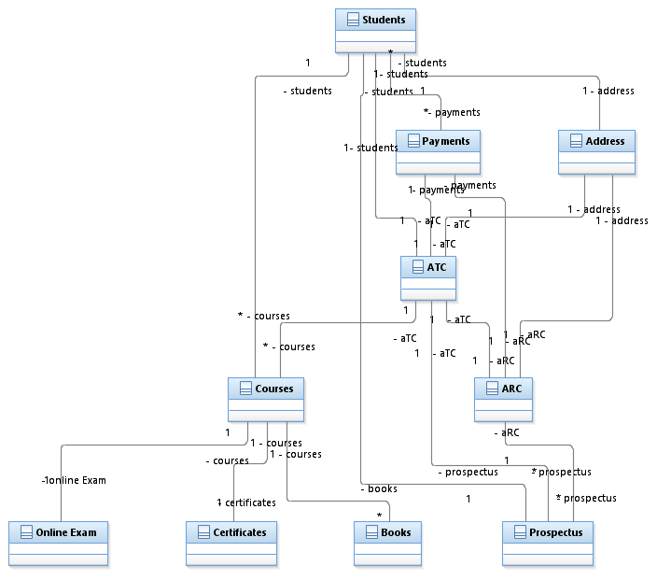

# Migration Impacts

## Legacy Access Database

The old data with historical data is maintained in MS Access. The new system will have capability to extract critical information from it for reporting and reference purpose only. The new system will not update any data in the legacy database.

# Dynamic Design

## Use Cases –

### CMO Creating ARC

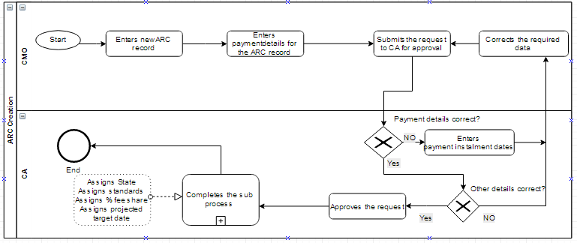

|  |  |
| --- | --- |
| Description | CMO create ARC record |
| Pre-Condition(s) | CMO has all the required information to create ARC record |
| Post-Condition(s) | CMO has successfully created ARC. |
| Main Path | 1. CMO enters the ARC record into the system. 2. Required ARC details are listed in the data model section. 3. CMO enters the payment details for this ARC. 4. CMO submits the record to CA for approval. 5. CA verifies the payment details and approves the payment details 6. CA assigns state to ARC. 7. CA assigns standards to ARC 8. CA defines % share for this ARC 9. CA assigns projected targets to ARC. |
| Alternate Path 1 | 1. CA verifies the payment details and finds missing payments. 2. CA adds installment dates to ARC record. 3. CA submits it back to CMO for payments 4. Once payments are completed CMO submits the request to CA. 5. Steps from 5 to 9 from Main Path will be followed. |
| Alternate Path n |  |

### License Fee management

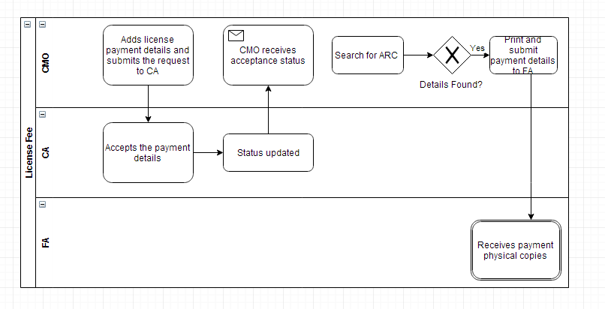

|  |  |
| --- | --- |
| Description | License fee management |
| Pre-Condition(s) | ARC exists in the system |
| Post-Condition(s) | FA receives the payment copies |
| Main Path | 1. CMO adds license payment details and submits this request to CA for approval 2. CA approves the license payment details. 3. CMO gets a notification once the request is approved. 4. CMO will search for the ARC 5. CMO finds the record and prints and submits the payment physical copy to FA |
| Alternate Path 1 |  |
| Alternate Path n |  |

### ATC creation by ARC/CO

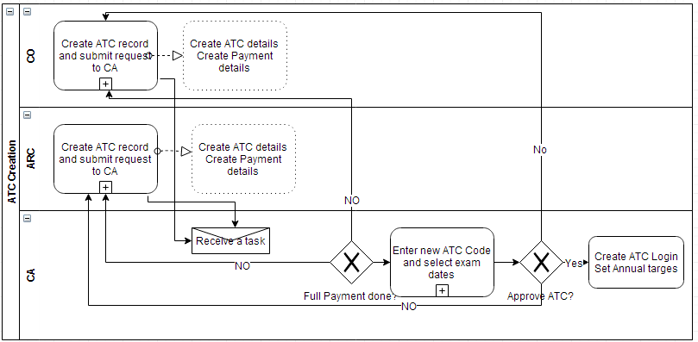

|  |  |
| --- | --- |
| Description | ATC creation |
| Pre-Condition(s) | ATC creation request has come in |
| Post-Condition(s) | ATC is created and credentials created. |
| Main Path 1 | 1. Based on where the ATC belongs, CO/ARC create ATC record. The respective owner of ATC also adds the payment details and the status. 2. These details are submitted to CA for approval. 3. CA receives a notification when the request is submitted. 4. CA verifies the payment status. 5. If payment is received, CA enters the new ATC code and selects exam dates for ATC. 6. If all the details are correct, CA approves the ATC record. 7. Once ATC records is approved, login credentials are created. 8. CA sets the annual targets to this ATC record. |
| Alternate Path 1 | 1. If CA rejects the payment details due to issues, - like Payment is not received, or payment is not cleared, the request is rejected by CA. 2. The rejection status is visible to ARC/ATC on the portal with comments for reason of rejection. |
| Alternate Path n | 1. If CA finds any issues with the ATC record details, the request is not approved. 2. The status goes back to ARC/CO from where the request had come in. 3. ARC/CO updates/corrects the required details and re-submit the record to CA for approval. |

### Inward Book management

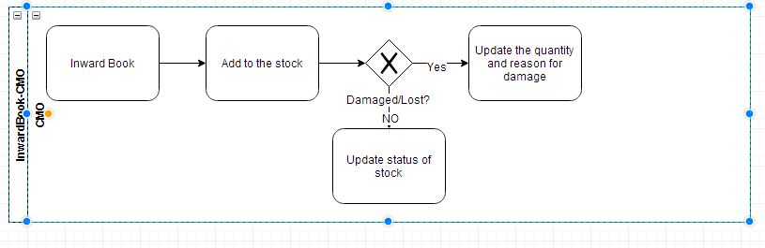

|  |  |
| --- | --- |
| Description | Inward book managements |
| Pre-Condition(s) | Inward book details are available to CMO. |
| Post-Condition(s) | Books stock reflects the current count and status. |
| Main Path | 1. CMO receives all the required information about the books. 2. CMO adds these details to the stock. 3. CMO verifies if there is any damage to the books of if there is any missing book. 4. If CMO does not find any damage or missing book, the stock is updated with respective status. |
| Alternate Path 1 | 1. If CMO finds a missing book from the record or damage to any of the books, CMO updates the number and adds relevant status and reason. |
| Alternate Path n |  |

### Student inquiry management

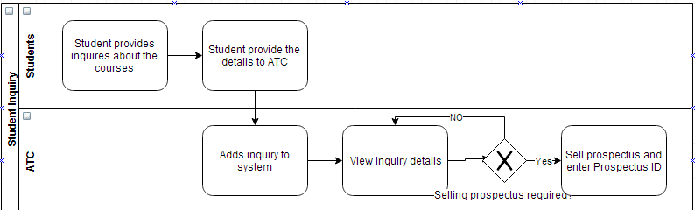

|  |  |
| --- | --- |
| Description | Student inquiry management at ATC |
| Pre-Condition(s) | Students come for inquiry |
| Post-Condition(s) | Student entry is made with the issued prospectus ID |
| Main Path | 1. Students come to ATC for inquiry about courses 2. Students provide their details to the ATC. 3. ATC creates a record of the inquiry into the system. 4. ATC verifies the inquiry details and verifies if the prospectus is issued to the student. 5. If prospectus is already issued, then ATC updates the required details and close the inquiry. |
| Alternate Path 1 | 1. If ATC finds no prospectus issued to the student for this inquiry, ATC sells a prospectus and adds the prospectus ID against the inquiry. |
| Alternate Path n |  |

### Students registration management

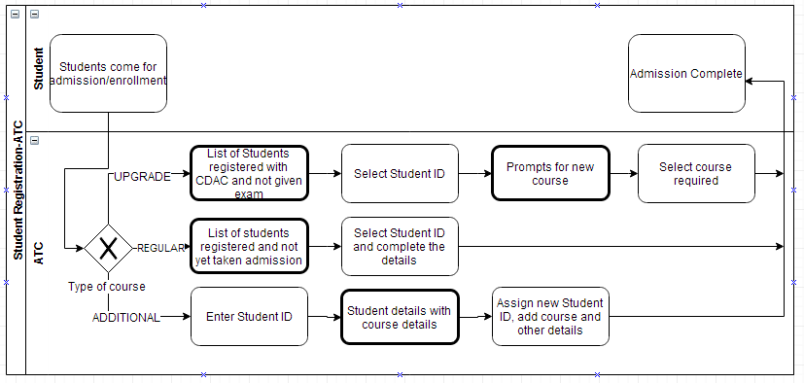

|  |  |
| --- | --- |
| Description | Student registration management. |
| Pre-Condition(s) | Students come for admission/enrollment to courses. |
| Post-Condition(s) | Students are enrolled for the course. |
| Main Path | 1. Students come to ATC for admission. 2. ATC learns from students which type of admission required. 3. ATC selects the type as Regular. 4. ATC selects the student record from the list. 5. ATC fills other details – details of course, fees, dates, status and batch. 6. ATC submits the student details for registration. Student ID is generated. 7. Student gets a Student ID and course details. |
| Alternate Path 1 | 1. ATC selects the student type as Upgrade. 2. List of students that are registered with CDAC but have not given exam yet will appear on the screen. 3. ATC will selects the student record (the record will contain Student ID already) 4. Screen prompts for new course to be selected. 5. ATC will select the required course from drop down. 6. ATC submits the record. 7. Student gets the course details. |
| Alternate Path n | 1. ATC selects student type as Additional. 2. ATC searches with the old Student ID. 3. Details of the old Student ID with course details appear on screen. 4. ATC gives new Student ID and add new course to the new Student ID. 5. ATC submits the details. 6. Students gets the course details with new Student ID. |
| Note | Upgrade: If existing students having registered with CDAC already and have not given their exams, wants to take up new course.  Regular: These are the students have enrolled, but has not completed the registration yet.  Additional: Student has registered for course and given exam already, needs to take up new course. (Additional will always be after the certification) |

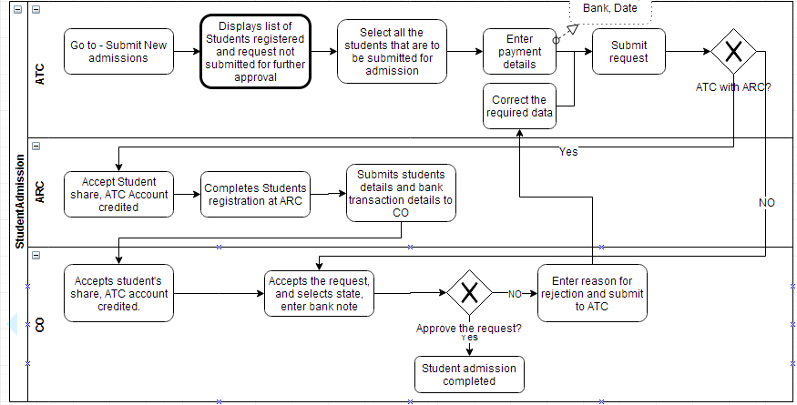

|  |  |
| --- | --- |
| Description | ATC submitting admissions to ARC/CO |
| Pre-Condition(s) | ATC has the list of students to be submitted for admission |
| Post-Condition(s) | Students’ admission completed. |
| Main Path | 1. ATC search for new admissions. 2. Screen displays the list of students recently got admissions and not submitted to ARC/CO. 3. ATC selects all the student records that are to be submitted for approval from CO/ARC. 4. ATC enters the payment details against all the student records – Payment details will contain DD number, bank, date and Amount. 5. ATC submits these students records with payment details to ATC/CO based on where the ATC belongs to. 6. If ATC is with ARC, ARC receives this notification. 7. ARC accepts the payment share, completes the student registration process at ARC. 8. The DD amount should be equivalent to the registration amount (number of registrations) submitted and to be verified before details are submitted to CO/CA 9. Provision for entering %age tax and need to be calculated 10. Submits the students’ details with Bank transaction details to CO. 11. CO approves the request and selects the state for this ATC record and complete the registration. |
| Alternate Path 1 | 1. If ATC is with CO. 2. CO gets the student registration request. 3. CO accepts the share, and ATC account is credited with their share. 4. This is not actual monitory transaction but just for record in the system to track. For actual amount ARC/ATC will have to verify their individual bank accounts. 5. Step 8 onwards followed as above. |
| Alternate Path n | 1. If CO finds issues, CO rejects the registration and ATC is notified about the same. 2. ATC corrects the required data and submit the request either to ARC/CO as required. |

### Online examination

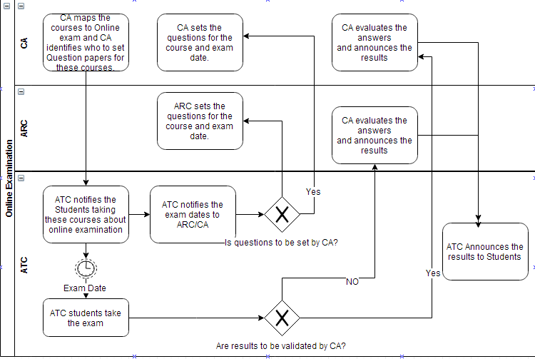

|  |  |
| --- | --- |
| Description | Online examination process |
| Pre-Condition(s) | Courses are identified for Online examination |
| Post-Condition(s) | Students get the online exam results. |
| Main Path | 1. CA identifies the courses that can be conducted online. 2. CA identifies the responsible owner for setting the questions and answer evaluation. 3. CA maps the courses to online examination and assigns the responsibility of preparing questionnaires and evaluation to either CA or ARC 4. At ATC, students enroll for courses. If Course is mapped to online examination, students are informed about the same. 5. ATC sends the eligible students ready to take exam to CA/ARC. CA/ARC defines the exam dates for those students and inform the ATC about the same. The examination code is shared with the ATC at a pre-agreed time (usually 30 mins before the exam). The student has to enter their registration number and the exam code to write the exam. 6. CA/ARC receives a notification of the exam, CA/ARC set the question papers online. 7. At ATC, students take the online exam on the date of examination. 8. The results submitted will be received by ARC/CA based on the responsibility set. 9. Answers are evaluated and results are submitted to ATC. 10. ATC announces the results to students. |
| Alternate Path 1 | 1. Question are picked from existing Question bank based on an agreed randomization pattern. 2. Step 5 onwards followed as above. |
| Alternate Path n |  |

# Interface Changes

|  |  |  |  |
| --- | --- | --- | --- |
| **​Sr No** | **Provider** | **Consumer** | **Description** |
| Int_01 | CDAC | ARC | Payment details |
| Int_02 | ARC | ATC | Payment details |
| Int_03 | CDAC | ARC | Prospectus requests/details |
| Int_04 | ARC | ATC | Prospectus requests /details |
| Int_05 | CDAC | ARC | Books requests/details |
| Int_06 | ARC | ATC | Books requests/details |
| Int_07 | ATC | ARC/CA | Online exam dates |
| Int_08 | ARC/CA | ATC | Online examination papers |
| Int_09 | ATC | ARC/CA | Answers by each student |
| Int_10 | ARC/CA | ATC | Evaluation results for each student. |

# Detailed Low level impacts

To be updated when the requirements freeze.

# Transition Plan

1. Are the changes (for each component) need to be switchable or not?

***No***

1. Should the old and new solution will run in parallel or not, and if they are at what point the old solution will be stopped

***The old and the new version should not run in parallel.***

1. Any data migration activities are needed or not.

***The system should allow capability to lookup old data. The data is currently in MS Access database. To which details will be shared.***

# Process Impact

# *TBD*

# E2E Testing Strategy

# *TBD*

# Non Functional

*Total volume of new students per month based upon which the system hardware/storage can be decided.*

*Mapping of courses to the centers to students – that define the transactional records.*

# Financial Aspects

## Option A

A high level effort estimation is described below.

### Development

Estimating the development effort of 720 man days.  
Estimated Project management effort 180 man days.  
Estimated resources:

* Four Developers, a mix or junior and senior developers averaged @ Rs, 840 per day/ per resource
* One Project Manager, a middle level project manager @ Rs. 1000 per day / per resource.

### Iteration / Feedback / Bug Fix / UAT

Estimating the development effort of 30 man days.  
Estimated resources:

* Project Manager and respective module/feature developer. No extra cost added.
* C-DAC representation for UAT and Feedback.

### Maintenance (AMC)

Estimating the maintenance effort of 360 man days additionally backed up by hosting and disaster recovery provisions.  
Estimated resources:

* One Developer, and a full time middle level programmer who will maintain the portal and look into in life requests and issues @ Rs, 840 per day/ per resource.
* Hardware/Infrastructure/Hosting cost @ 500 per day (optional if hosted on C-DAC’s infrastructure)

## Option B

A high level effort estimation is described below.

### Development

Estimating the development effort of 720 man days.  
Estimated Project management effort 180 man days.

### Iteration / Feedback / Bug Fix / UAT

Estimating the development effort of 30 man days.  
Estimated resources:

* Project Manager and respective module/feature developer.
* C-DAC representation for UAT and Feedback.

### Maintenance (AMC)

Estimating the maintenance effort of 360 man days additionally backed up by hosting and disaster recovery provisions.  
Estimated resources:

* One Developer, and a full time middle level programmer who will maintain the portal and look into in life requests and issues @ Rs, 840 per day/ per resource.
* Hardware/Infrastructure/Hosting cost @ 500 per day (optional if hosted on C-DAC’s infrastructure)

# Appendix

|  |  |
| --- | --- |
| Name | Reference |
| Data mapping sheet |  |
|  |  |
|  |  |
|  |  |

# Glossary

|  |  |
| --- | --- |
| C-DAC | Center for Development of Advanced Computing |
| ARC | Advanced Regional Center |
| ATC | Advanced Training Center |
| CA | Admin User for C-DAC |
| CMO | Centre Management Operator for C-DAC/ARC |
| CO | Computer Operator for C-DAC/ARC/ATC |
| FA | Finance/Accounts for C-DAC |